**Digital Image Processing**

 Digital image processing is the use of algorithms and mathematical models to process and analyze digital images. The goal of digital image processing is to enhance the quality of images, extract meaningful information from images, and automate image-based tasks.

### The basic steps involved in digital image processing are:

1. Image acquisition: This involves capturing an image using a digital camera or scanner, or importing an existing image into a computer.
2. Image enhancement: This involves improving the visual quality of an image, such as increasing contrast, reducing noise, and removing artifacts.
3. Image restoration: This involves removing degradation from an image, such as blurring, noise, and distortion.
4. Image segmentation: This involves dividing an image into regions or segments, each of which corresponds to a specific object or feature in the image.
5. Image representation and description: This involves representing an image in a way that can be analyzed and manipulated by a computer, and describing the features of an image in a compact and meaningful way.
6. Image analysis: This involves using algorithms and mathematical models to extract information from an image, such as recognizing objects, detecting patterns, and quantifying features.
7. Image synthesis and compression: This involves generating new images or compressing existing images to reduce storage and transmission requirements.
8. Digital image processing is widely used in a variety of applications, including medical imaging, remote sensing, computer vision, and multimedia.

## What is an image?

An image is defined as a two-dimensional function,**F(x,y)**, where x and y are spatial coordinates, and the amplitude of **F** at any pair of coordinates (x,y) is called the **intensity** of that image at that point. When x,y, and amplitude values of **F** are finite, we call it a **digital image**.   
In other words, an image can be defined by a two-dimensional array specifically arranged in rows and columns.   
Digital Image is composed of a finite number of elements, each of which elements have a particular value at a particular location.These elements are referred to as picture elements,image elements,and pixels.A Pixel is most widely used to denote the elements of a Digital Image.

## Types of an image

1. **BINARY IMAGE**– The binary image as its name suggests, contain only two pixel elements i.e 0 & 1,where 0 refers to black and 1 refers to white. This image is also known as Monochrome.
2. **BLACK AND WHITE IMAGE**– The image which consist of only black and white color is called BLACK AND WHITE IMAGE.
3. **8 bit COLOR FORMAT**– It is the most famous image format.It has 256 different shades of colors in it and commonly known as Grayscale Image. In this format, 0 stands for Black, and 255 stands for white, and 127 stands for gray.
4. **16 bit COLOR FORMAT**– It is a color image format. It has 65,536 different colors in it.It is also known as High Color Format. In this format the distribution of color is not as same as Grayscale image.

## Image as a Matrix

As we know, images are represented in rows and columns we have the following syntax in which images are represented: 

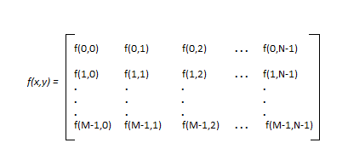

The right side of this equation is digital image by definition. Every element of this matrix is called image element , picture element , or pixel.

### Advantages of Digital Image Processing:

1. Improved image quality: Digital image processing algorithms can improve the visual quality of images, making them clearer, sharper, and more informative.
2. Automated image-based tasks: Digital image processing can automate many image-based tasks, such as object recognition, pattern detection, and measurement.
3. Increased efficiency: Digital image processing algorithms can process images much faster than humans, making it possible to analyze large amounts of data in a short amount of time.
4. Increased accuracy: Digital image processing algorithms can provide more accurate results than humans, especially for tasks that require precise measurements or quantitative analysis.

### Disadvantages of Digital Image Processing:

1. High computational cost: Some digital image processing algorithms are computationally intensive and require significant computational resources.
2. Limited interpretability: Some digital image processing algorithms may produce results that are difficult for humans to interpret, especially for complex or sophisticated algorithms.
3. Dependence on quality of input: The quality of the output of digital image processing algorithms is highly dependent on the quality of the input images. Poor quality input images can result in poor quality output.
4. Limitations of algorithms: Digital image processing algorithms have limitations, such as the difficulty of recognizing objects in cluttered or poorly lit scenes, or the inability to recognize objects with significant deformations or occlusions.
5. Dependence on good training data: The performance of many digital image processing algorithms is dependent on the quality of the training data used to develop the algorithms. Poor quality training data can result in poor performance of the algorit

# What is a Pixel?

A **pixel is the smallest unit of a digital image or display and stands for “picture element.”** It is a very small, isolated dot that stands for one color and plays the most basic part in digital images.

Pixels when combined help to create the mosaic of colors and shapes contributing towards visual content being displayed on screens such as smartphones, computers TVs, etc. In digital imaging, a grid of pixels can be seen and the combination of thousands or millions of such ‘pixel’ creates an overall visual representation that users see on their screens.

Pixels are the smallest fragments of a digital photo. Pixels are tiny square or rectangular elements that make up the images we see on screens, from smartphones to televisions.

Every pixel in the image is marked by its coordinates and contains information about color and brightness or sometimes opacity level has a place for each and all pixels.

Understanding pixels is crucial in digital imaging and photography, as they determine the resolution and quality of an image. An image consists of several pixels that define its resolution. 1920x1080 would typically be seen as a resolution height and width related to the Full HD screen.

* **Pixel (Picture Element):**A pixel is the smallest part of a computer picture. It shows one spot in the whole photo. Every little square has information about color, brightness and position. When these squares are put together with others they make a complete picture that we can see. Pixels are the parts that make up digital screens. They arrange together to show letters, pictures and videos.
* **Resolution:** Resolution **means the number of little squares, called pixels, in a digital photo**. It's usually measured by width and height size. Using more details gives better results in pictures. **Usual measurements for resolution are**[**pixels per inch (PPI)**](https://www.geeksforgeeks.org/difference-between-ppi-and-dpi/) for pictures that get printed and pixels per centimeter (PPCM). For example, a screen that can show pictures at 1920 x 1080 has more tiny dots or pixels from left to right and has 1920 pixels horizontally and 1080 pixels vertically.
* **Pixel Density:**Display resolution is the number of tiny dots on a screen, often shown as pixels per inch (PPI) for screens. It **decides how clear a picture looks, and more pixels make it sharpe**r. Mobile phones with good picture quality often have lots of tiny dots on the screen, making images colorful and clear.
* **Color Depth:**Bit depth, also called color depth, means how many bits show the color of each pixel. Usual values are 8-bit, 16-bit and 24-bit color levels. The more bits a pixel has, the more colors it can show. This makes for a wider and deeper range of colors.

## What is Hue?

The **hue** of a color is a component of its chromaticity. Red, green, and blue are the three main colors of light. It is why televisions, computers, and other electronic color visual displays use a trio of red, green, and blue phosphors to generate all electrically conveyed colors. Hue is a single value that describes the color of something and is typically measured in degrees. It has the colors red, orange, yellow, green, blue, purple, and magenta all the way back to red. Although, magenta and pink colors are not light frequencies, and a rainbow may prove it. It begins with red and progresses to different colors, but it doesn't contain magenta and pink because they are not genuine frequencies humans can see.

## What is Saturation?

**Saturation**: The intensity of a color. As saturation increases, colors appear sharper or purer. As saturation decreases, colors appear more washed-out or faded

**Saturation** is defined by the purity of the color and its distance from the grey color. If a color has much more greyness, it has a lower saturation level. Moreover, saturation could be viewed as the hue's dominance in the color. The outermost edge of the hue wheel includes the pure hue; as you move inside the wheel to the centre, which contains grey, the hue steadily drops, and the saturation likewise falls. It relates to a physical property known as the excitation property, which measures the percentage of brightness mixed with the dominant or pure color.

There are various key differences between **Hue and Saturation**. Some of the key differences between Hue and Saturation are as follows:

1. Hue is an essential property of light that aids in differentiating different colors from one another. On the other hand, saturation specifies how intense the color is at the specified hue or the degree of vividness.
2. Hue is determined by measuring the difference between white light and various color of light. In contrast, saturation is determined by the amount of grey in color.
3. The degree of the angle is utilized to measure the Hue. On the other hand, saturation is usually measured in a percentage.

**Brightness**

* **Brightness**: The chromatic notion of intensity.

**Hue and Saturation** are characteristics of the color. The primary distinction between them is that whereas saturation refers to a hue's level of brightness and dullness, hue is the purest form of a color. Colors are often measured from **0 to 360 degrees**, with **red at 0, green at 120**, and **blue at 240**.

## Most color wheels work in degrees, with angles measured on the color wheel, but in the point of computer systems, the idea is entirely different, with everything existing in binary values. A byte is utilized to save the color in the computer systems memory, which falls a little short because it can scale from 0 to 255. As a result, just 240 values are required to store the hue, with the RGB (Red, Green, Blue) colors allocated in increments of 80, such as red at the lowest frequency of the color, 80 at the green, and 160 at blue.

## Brightness

Brightness is a visual perception in which a source appears to be reflecting light. Brightness is a subjective property of an object which is being observed. Brightness is an absolute term and different from lightness.

A color screens use three colors i.e., RGB scheme (red, green and blue) the brightness of the screen depends upon the sum of the amplitude of red green and blue pixels, and it is divided by 3.

DIP Brightness and Contrast

The perception of brightness depends upon the optical illusions to appear brighter or darker.

When the brightness is decreased, the color appears dull, and when brightness increases, the color is clearer.

In mobile devices, when brightness setting is high, device battery drains fast as compare to the low setting.

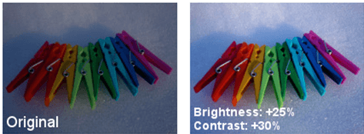

**Region**

**Region** is a group of connected pixels with similar properties. Regions are also referred to as objects, connected components, or blobs. They are important for interpreting an image because they can correspond to objects in a scene.

Here are some properties of regions:

* **Area**: The area of a region
* **Center of mass**: The center of mass of a region
* **Orientation**: The orientation of a region
* **Bounding box**: The bounding box of a region
* **Boundary descriptors**: Boundary length, diameter, and curvature
* **Regional descriptors**: Perimeter, compactness, and mean value

**Distance Measures** Assuming there are two image points with coordinates (x, y) and (s, t). a distance measure is normally conduced for evaluating how close two these two pixels are and how they are related. A number of distance measurements have been commonly used for this purpose

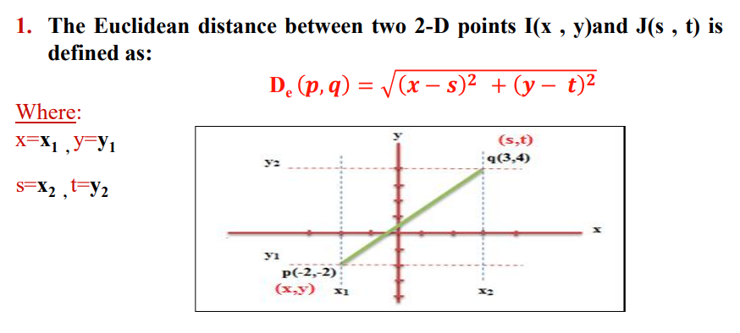

## Types of Image

### Binary Images

The simplest kind of images are binary images, which can have two values—typically black and white or 0 and 1. Because only one binary digit is required to represent each pixel, a binary image is referred to as a 1-bit image. Applications like optical character recognition ([OCR](https://www.geeksforgeeks.org/what-is-optical-character-recognition-ocr/)) rely on these kinds of images when the only information needed is a general shape or outline.

A threshold operation, in which every [pixel](https://www.geeksforgeeks.org/what-is-a-pixel/)above the threshold value is made white ('1') and those below it are made black ('0'), is frequently used to create binary images from grayscale images.

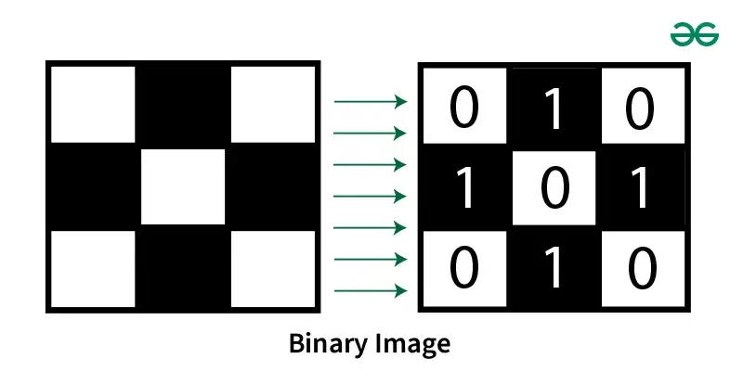

### Gray-Scale Images

Gray-scale images are referred to as monochrome (one-color) images in the figure below. The number of available gray levels is determined by the number of bits used for each pixel. The normal dark scale picture contains 8bits/pixel information, which permits us to have 256 different dim levels. In applications like clinical imaging and space science, 12 or 16 pieces/pixel pictures are utilized. When a small portion of the image is magnified to make it easier to see details, these additional gray levels come in handy.

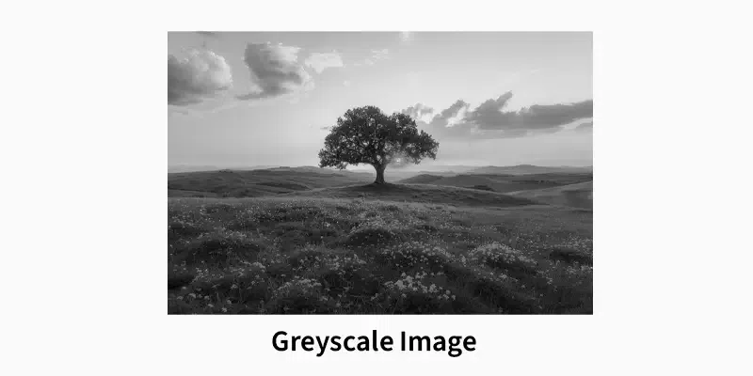

### Color Images

Color images can be represented as three-band monochrome image data, with each band representing a distinct color. The gray-level information for each spectral band is the actual data that is kept in the digital image data. The colors red, green, and blue are used to represent typical color images. The corresponding color image would have 24-bits per pixel if the 8-bit monochrome standard were used as a model. This is eight bits for each of the three color bands—red, green, and blue.

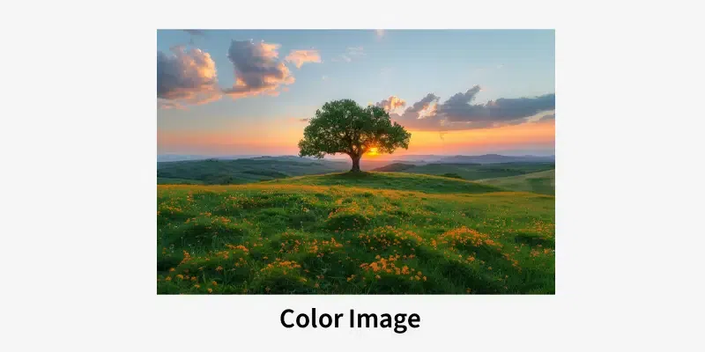

### Multispectral Pictures

Multispectral pictures ordinarily contain data outside the typical human perceptual reach. X-ray, infrared, ultraviolet, acoustic, and radar data are all examples of this. Because the information being represented is not directly visible to the human system, these are not images in the usual sense. In any case, the data is much of the time addressed in visual structure by planning the different ghastly groups to RGB parts.

